Day 15 - Introduction to Azure NAT Gateway

What is Azure NAT Gateway?
Note: NAT stands for Network Address Translation.
An Azure NAT Gateway is a networking service provided by Microsoft Azure that allows outbound internet connectivity for resources in a virtual network (VNet) without exposing those resources directly to the internet.
We can use Azure NAT Gateway to let all instances in a private subnet connect outbound to the internet while remaining fully private.
Using a NAT Gateway, resources in private subnets can initiate communication with the public internet, but the public internet cannot initiate communication with those resources.
Azure NAT Gateway Architecture:
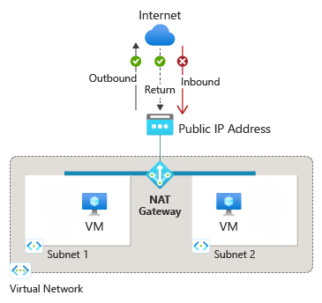

When to Use Azure NAT Gateway:
- Outbound Internet Access from Private Subnets:
  - Your resources (e.g., VMs, containers) don’t have public IPs but need to access the internet (e.g., for software updates, API calls, etc.).
- Static Outbound IP Address Requirement:
  - You want all outbound traffic to use a consistent public IP address or range, especially useful when:
    - Third-party services require IP whitelisting.
    - You need consistent logs or audits of IP usage.
- Large-Scale or High-Throughput Workloads:
  - You expect thousands of connections or high bandwidth usage and need automatic scaling without manually managing IPs or SNAT ports.
- Improved Security Posture:
  - You want resources to initiate connections only, with no inbound exposure, unlike load balancers or public IPs.
- Centralized Outbound Management:
  - You want a central point to control and manage all outbound internet traffic from multiple resources or subnets.

Azure NAT Gateway provides outbound connectivity for many Azure resources, including:
• Azure virtual machines or virtual machine scale-sets in a private subnet.
• Azure Kubernetes Services (AKS) clusters.
• Azure Container group.
• Azure Function Apps.
• Azure Firewall subnet.
• Azure App Services instances (web applications, REST APIs, and mobile backends) through virtual network integration.
• Azure Databricks or with virtual network injection.
• And more.

Note: In AWS, the equivalent of Azure NAT Gateway is " NAT Gateway "

